
Muromachi Musicals: Resetting Kyōgen in a Modern Medium Author(s): Gart T. Westerhout
Reviewed work(s):
Source: Asian Theatre Journal, Vol. 24, No. 1 (Spring, 2007), pp. 262-268 Published by: University of Hawai'i Press
Stable URL: http://www.jstor.org/stable/4137119
Accessed: 30/04/2012 09:17
Your use of the JSTOR archive indicates your acceptance of the Terms & Conditions of Use, available at http://www.jstor.org/page/info/about/policies/terms.jsp
JSTOR is a not-for-profit service that helps scholars, researchers, and students discover, use, and build upon a wide range of content in a trusted digital archive. We use information technology and tools to increase productivity and facilitate new forms of scholarship. For more information about JSTOR, please contact support@jstor.org.
 | University of Hawai'i Press is collaborating with JSTOR to digitize, preserve and extend access to Asian Theatre Journal.

Muromachi Musicals: Resetting Kyogen in a Modern Medium
Gart 7: Westerhout
Gart T Westerhout introduces the Osugi Musical Theatre (OMT), located in the mountain village of Osugi (pop. 75), two hours north of Kyoto by train. Formed in 1995 to produce original theatre at the community level, the group takes Japanese theatre, folklore, and history and presents it in a new light. The primarily Japanese group performs in Japanese and has appeared in more than forty different venues, including four overseas tours.
Gan T Westerhout is an associate professor at Kinjo College in Hakusan, Ishikawa, and the founding director of Osugi Musical Theatre. He writes or adapts the group's musicals, including composing most of the music. The website of his group is osugimusicaltheatre.com.
The 1990s saw diverse experiments by professional kyogen actors. Nomura Mansai (b. 1966) performed kyogen in large halls with super-titles, lighting, and special effects—a "super-kyogen" recalling the even more high-tech "super-kabuki" plays of Ichikawa Ennosuke III. The late Nomura Mannoje (VIII, 1959-2004) reinterpreted Snow White as a kyogen farce, while the Shigeyamas of Kyoto adapt French farce, Beckett parables, and rakugo stories to kyogen style. The Osugi Musical Theatre has taken the opposite approach: transposing kyogen stories to the musical stage. To date we have produced two musicals based on kyogen: Mangetsu no itazura (Moonlight Mischief) and Kimodameshi (The Test of Courage). Our goal in producing these shows was to share the joy of kyogen stories in the modern stage medium of the musical.
Asian Theatre jo al, vol. 24, no. 1 (Spring 2007). © 2007 by University of Hawai'i Press. All rights reserved.
Moonlight Mischief
Moonlight Mischief combines the kyogen plays Busu (The Delicious Poison) and Fukitori (Fluting for a Wife), with the addition of fourteen songs. It was performed a dozen times in 1998, then revised and reset, and performed another dozen times in 2005. For the first run we set the show in medieval Europe, corresponding roughly to the era that gave birth to kyogen in Japan. In the revival, we reset it in 1950s America.
The Delicious Poison, arguably the best-known play of the kyogen repertoire, tells the story of two mischievous servants who disobey the Master's orders and eat his precious sugar in his absence. In the rarer Fluting for a Wife, a Man has a dream that should he play the flute on the night of the full moon, a woman fit to be his bride shall appear. He cannot play the flute, so enlists a friend to play in his stead, and when the "Woman" appears, predictable confusion ensues. (She turns out to be a fox in the literal sense of the word!)
In Moonlight Mischief the two plays are broken down into scenes that play alternately (and once simultaneously), and are complemented by the addition of a chorus in the form of a moon-viewing party. The Master of The Delicious Poison is called away by his friend to play the flute in Fluting for a Wife. The play opens with a curtain-raising song that introduces some of the onomatopoeia of kyogen. One of the endearing qualities of kyogen is that the actors make whatever sound effects are needed with their own voices. The effects include animal cries as well as sounds representing the moving of objects. These do not appear in every play, but there are more than thirty such onomatopoeic expressions in all. The song introduces nine of them in a calland-response fashion, three of which later appear in the script of the play. (We used expressions found in Izumi School kyogen plays; some of them differ in Okura School versions.)
"Nani Ja Ru Ro?! KyOgen no Gion" (What's That?! KyOgen's Onomatopoeia)
(Chorus) Nani nani nani jya ru ro
(What's that, what's that, just what could it be?)
Byo byo byo—inu ja! (Byo byo byo—it's a dog!)
Kya kya kya—saru ja! (Kya kya kya—it's a monkey!)
Zuka zuka zuka—nokogiri ja! (Zuka zuka zuka—it's a saw!) Hora kyogen no gion! (See, kyOgen's onomatopoeia!)
(Chorus)
11411911.:*
P82 01-P ⁻-)Pip.oP
111Jt1.5¹¹4^{:1}0¹311¹1411 • •8⁰.0.1^{1,}*
Wang-16HW
88 9®10® 15B 1613
¹F1F 15:00 11:0D I :GO 15:00 i:00
?FP — 15:00 15:CO 19:00 15:C0 2n 4 II E 1 4 . atr>,
1:1.1
-••••
tape 78 •TrA.11 7845-r.ni n-s•clyfe871-,8,1,
*118
♦6824,8* c Dm.) tcnr*wort ^{r} rs,
t1076 1-46 -1824
11n27n
•EitlatfiVitV9-
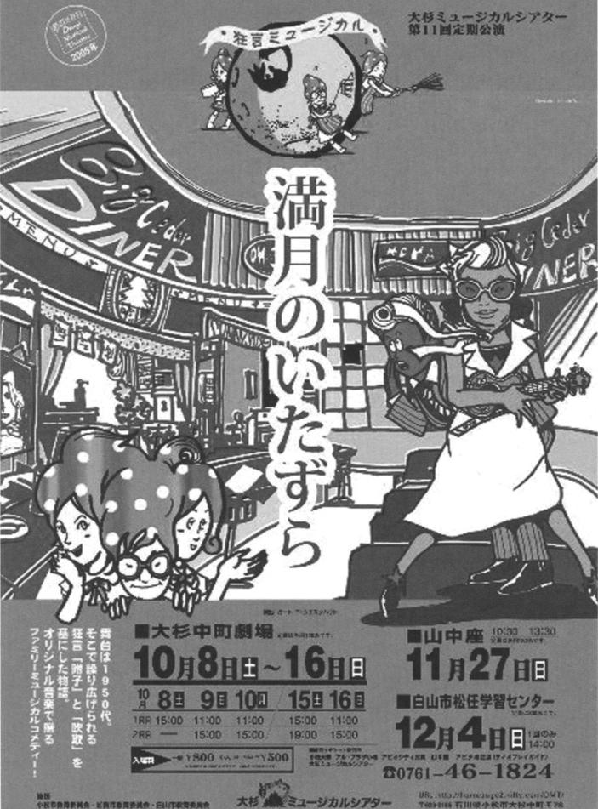
Men men meri—saku o nukeru (Mefi men men—sliding open a door or barrier)
Muri muri muri—futa o toru (Muri muri muri—removing a lid) Kottsuri (itai!)—hari o utsu! (Kottsuri—ouch!—pounding in an acupuncture needle)
Hora kyogen no gion! (See, kyogen's onomatopoeia!)
(Chorus)
Zarari, zarari—kakejiku yaburu! (Zarari zarari—tearing a hanging scroll)
Garari, chin!—chawan o want! (Garari, chin!—breaking a teacup)
Dobu dobu dobu—sake o tsugu! (Dobu dobu dobu—pouring sake) Hora kyogen no gion! (See, kyOgen's onomatopoeia!)
Included among the other songs in the show are three that set kyogen lyrics to new melodies. One, "Nagori no Sode" (Sleeves of Parting, from The Delicious Poison), becomes a 1950s doo-wop dance. Another, "Hyotan" (The Calabash, used in various kyogen plays), becomes a merry drinking song. The third, "Hitokuchi" (One Bite, also used in The Delicious Poison), starts as a solemn hymn in harmony, which segues into a rock-and-roll number. For our 2005 production, we had a four-piece band: piano, bass, flute, and percussion. More than half of the numbers were done to live accompaniment, and the rest to prerecorded music that allowed a broader range of instruments.
Other than the addition of the chorus and the split presentation of the two stories, we stayed quite true to each story line. To allow the flute player to sing as well as to play, we changed the flute to a concertina in the 1998 version, and to a ukulele in 2005. (Strictly speaking, a concertina in a medieval setting is anachronistic, as the instrument was not invented until the eighteenth century, yet it seemed to fit the atmosphere well.)
One feature of these split stories is that all the action (once the story proper begins) takes place on a stage with no set changes. The Delicious Poison set is stage left, Fluting for a Wife on stage right. When one scene ends, the actors hold a pose, the lights dim on that part of the stage, and come up on the other part as the other actors swing back into action, sometimes repeating the last line they spoke before the previous scene ended. In 1998, when we set the show in medieval Europe, the set was made to look like an art gallery; on The Delicious Poison side of the stage were three original paintings of interior scenes, while on the Fluting for a Wife side were two paintings of the outdoors. In our 1950s version, the former was set in a diner (Plate 5), and the
latter on a brick bridge with chain-link fence, reminiscent of a city pedestrian overpass.
Other than a few selected movements, we chose not to present the show in kyOgen style. Characters moved in a more modern and natural way, as befits the style of our musical. Delivery of lines was also modern and more up-tempo than that of traditional kyogen.
The core cast for Moonlight Madness is six, plus a chorus, which in our case varied from eight to twenty-three. In our final performance of 2005 we enlisted the support of local students for a chorus of 110, main cast of six, and band of five to make 121 on the stage.
The writing process for this play was a bit different than our normal process. I usually write OMT's plays in English and have them translated into Japanese. In this case we used, with his gracious permission, Don Kenny's English translations of the two plays. After splitting scenes and adding songs, Yoshimoto Etsuko, with reference to the original Japanese kyogen scripts, translated Kenny's English back into Japanese. She chose to modernize some words and phrases for more accessibility for the modern audience, so the resulting script was a mix of old and modern Japanese.
The Test of Courage
The other kyogen play we produced in musical style was our version of Yumiya Tar() (Bow and Arrow TarO), which we renamed The Test of Courage. TarO, who always boasts about being strong and brave, is widely thought of as a coward. When he denies this, his friends dare him to go deep into the forest at midnight, where lurks a dreaded demon.
The original kyogen features a cast of about six to eight actors, more than is typical. Our show featured anywhere from five to twenty players and was performed thirty times from 2001 to 2004, including a tour to Austria. The lead, an elementary school boy named Yamato Hayao, took the top male actor prize when we performed the show at the Yakumo International Theatre Festival in Shimane Prefecture in fall 2001. The rest of the roles were divided between adults and children.
As in Moonlight Madness, there were fourteen songs, two of which were set to kyOgen lyrics. We stayed true to the story, adding only two short scenes to the Izumi School script, with occasional changes to the language. The play was set in old Japan, with costumes made of recycled kimonos.
OMT's Other Musicals
Osugi Musical Theatre continues to bring a variety of theatre and music to the local community and beyond. The actors range from
age five to fifty-five (about half are children), all volunteers from the area. The audiences for our shows are mostly families, though we do have a good number of adults who come on their own. Our home theatre is an old community hall seating 150, which we are able to rent year round. We usually mount a new musical (or revival of one of our previous shows) each fall, and then take it on the road. Since our founding, we have presented more than two hundred performances of our plays and concerts.
OMT has put on several shows besides the kyogen musicals. Yokubari tengu I and II (The Greedy Goblin I and II) is about a tengu (long-nosed, red-faced goblin), inspired by a statue that stands in Osugi. Another was inspired by an old local village song, "Osugi Okoku: Uta no Sato" (Osugi Kingdom: Land of Song). Lucky was based on an old Japanese story from the Noto Peninsula but reworked and reset as a Wild West melodrama. We set haiku poet Matsuo Basho's 1689 visit to Komatsu in the twentieth century in Komatsu Internet Love Story, complete with several haiku set to music and including a mini-parody of Kanjincho (The Subscription List), the celebrated kabuki play based on a historical incident said to have taken place in Komatsu in the twelfth century. (Minamoto Yoshitsune was fleeing from his brother Yoritomo. Thanks to the bravado of his follower, Benkei, he managed to get through a barrier set up by Yoritomo's men.) Radio Osugi imagines the fictional first radio station in the village in the 1920s. Our one serious musical is based on the true story of a twelve-year-old Hiroshima girl named Sadako, who, ten years after the atom bomb was dropped, passed away from leukemia, but not before trying to fold one thousand paper cranes in the hope for a long life. We performed Heiwa no tori: Hiroshima no issan (Birds of Peace: Hiroshima's Legacy) in many venues, including tours to the Discovery Theatre at the Smithsonian Institution in Washington, DC, in 1999, and to La Crosse, Wisconsin, in 2006.
Summary
Our first kyogen show was warmly received by our audiences, which encouraged us to try the second and then later revive the first. One spectator wrote about our 1950s Mangetsu no itazura: "When I heard about the show, I was not sure why a Japanese traditional theatre form was being done in an American setting and medium. But as the story unfolded, the music, story, costumes, and set all worked together to bring the two worlds together and make it very appealing. The musical form gave kyogen new possibilities" (Kondo Hiroshi, letter, 15 December 2005).
Yamato Kazuyo, a kindergarten teacher, storyteller, and six-year
OMT cast member who has performed in both of our kyogen musicals, offered her reflections: "The lines are much different from everyday language, and took some getting used to. But through repeated practice we could feel the rhythm of the language, and grew to like it. The stories that we used were not unlike folk tales or legends, and in this way were easy for the audience to understand. Kyogen is interesting, and by putting it in Western musical form the audiences could see it in a way they had not before. I was happy to have experienced Japanese culture in a new way" (Yamato Kazuyo, letter, 12 January 2006).
Bringing kyogen to the stage as a musical has presented various challenges, not the least of which was how to present a new interpretation of an old and respected Japanese theatre form without being seen as poking fun at it. We hope to have achieved this by staying true to the storyline of each show and enriching it with music and dance of modern musical form. Many kyogen stories have an appeal that can speak across cultures and one that has endured through time. The reception to our tour in Austria with The Test of Courage was very positive. With a very limited number of German-language supertitles, we were able to get the story across in an entertaining way. We have tried to respect kyogen at all times, using it as a base for something new. We hope to continue along the same lines, providing opportunities for both cast and audiences to experience the joy of kyigen through more Muromachi musicals.

